Transport and Land-use – Making the Connections

6pm, Wednesday 9th April 2014

Godfrey Mitchell Theatre, Institution of Civil Engineers, One Great George Street, London, SW1
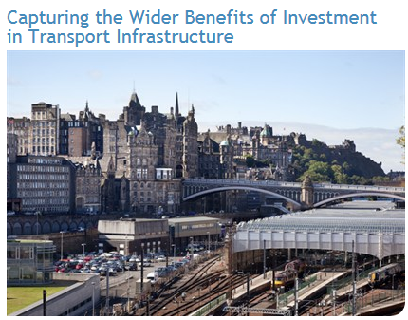

RTPI’s recent report on capturing the wider
benefits of transport investment discussed
the role of transport infrastructure in
delivering for the UK the kinds of places
where people want to live, work and invest.

Speakers include David Pendlebury from
RTPI. More speakers to be confirmed.

Please come along and join the discussion.

Refreshments will be available from 17:30hrs

Booking your place - New online booking procedure - To book your place at this event please visit http://www.ice.org.uk/Event?ID=2467. If you do not currently have access to a MyICE account please register and this will allow you to book yourself on all future TPS events. Please note if you are a Corporate/Stakeholder member of TPS you will need to register as a non-member rather than a member as the membership number relates to ICE not TPS.

If you require advice or are unable to book yourself on this event please contact Pauline Arundel on pauline.arundel@ice.org.uk or 020 7665 2236.

Please note that entrance to the event is free for TPS members with their membership card. A £10 fee applies to non-members. The fee is payable on the evening.

Certificates of attendance are available to TPS members. Please ensure you sign the register on the night and indicate your request for a certificate and these will be issued to you electronically after the event.

